Step 1 - Students must access or create their Student Portal inside Aeries

- Go to your school’s Home Page and click on the ‘Parent/Student Portal’ link within the I’m Looking For section (top of website)

- Or go directly to the Aeries login at… https://portal.capousd.org/ParentPortal/LoginParent.aspx?page=default.aspx

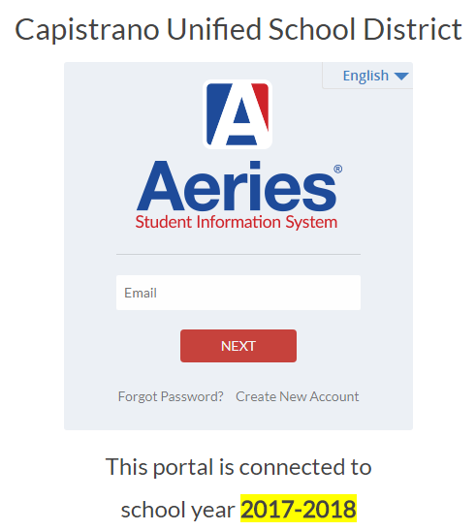

- Students can access their Aeries accounts with their personal email address and passwords or they must create an account using their personal email address and passwords.

- Once they have access to their Aeries-based Student Portals, they will see this screen…

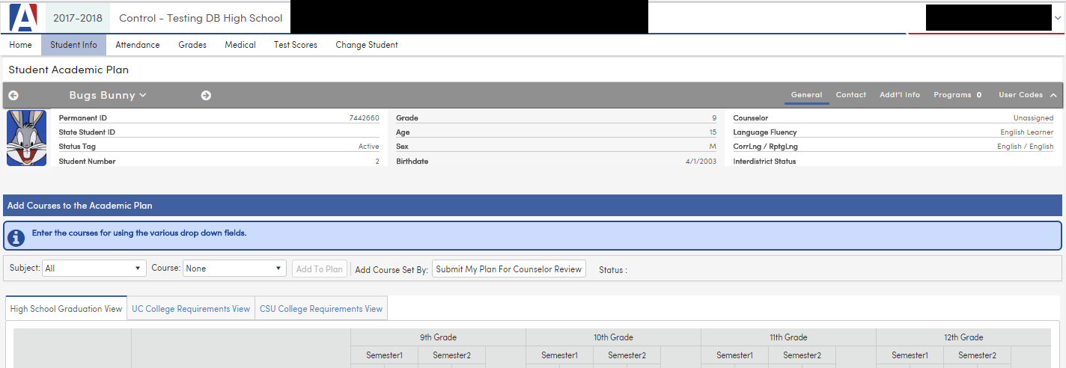

Step 2 – Create the 4-Year Plan

- Click on the ‘Student Info’ link (circled in red) in the top-left of the Home page and select the ‘Academic Plan’ from the dropdown menu. You should see the following screen…

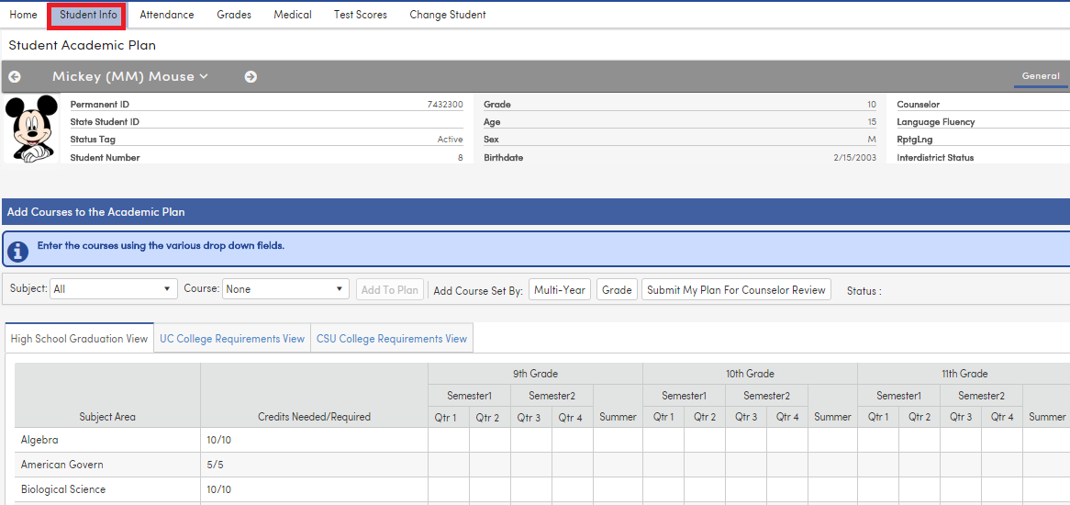

- To add courses, select a subject, then the course, then click ADD TO PLAN
- Select grade level and term from the drop downs, the click PLACE THE COURSE

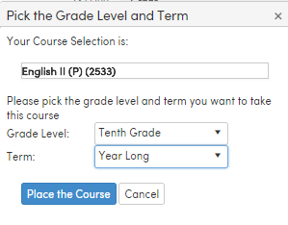

Multi-Year packets have yet to be set up at your site.

